**User Manual**

This application is created for flooring company to calculate and track customer orders. Flooring application has four tabs. Customer tab will be used to input name and address of the customer. Flooring tab is used to input length width and type of flooring. Calculate tab is used to calculate area and cost of the flooring, this tab has three buttons. Summary tab is used to display the summary of the current order.

**Customer Tab:**

In customer ab user will in put customer name and customer address both fields are mandatory to complete the order.

Following is the customer tabs:

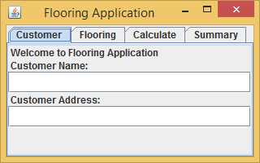

If we submit order without entering name and address following message will be displayed.

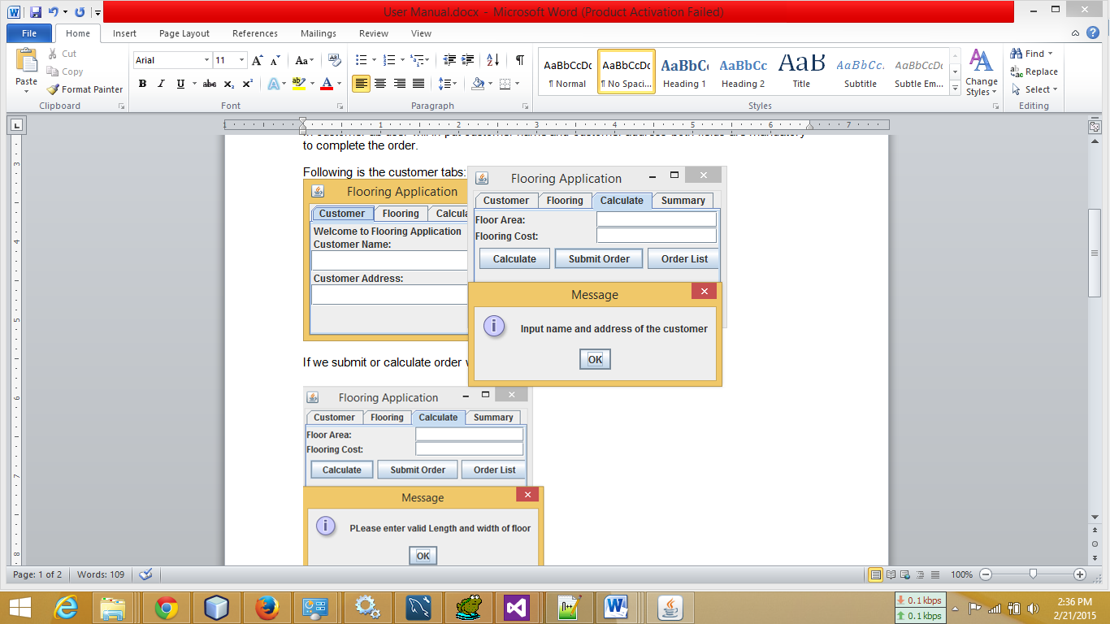

**Flooring Tab:**

Flooring tab is used to input length and width of floor and type of flooring available. In length and width field only numeric vales are accepted.

Following is the screen shot of the flooring tab:

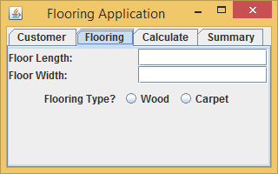

If numeric values are not entered in length or width field or are left blank following message will appear before calculating or submitting orders.

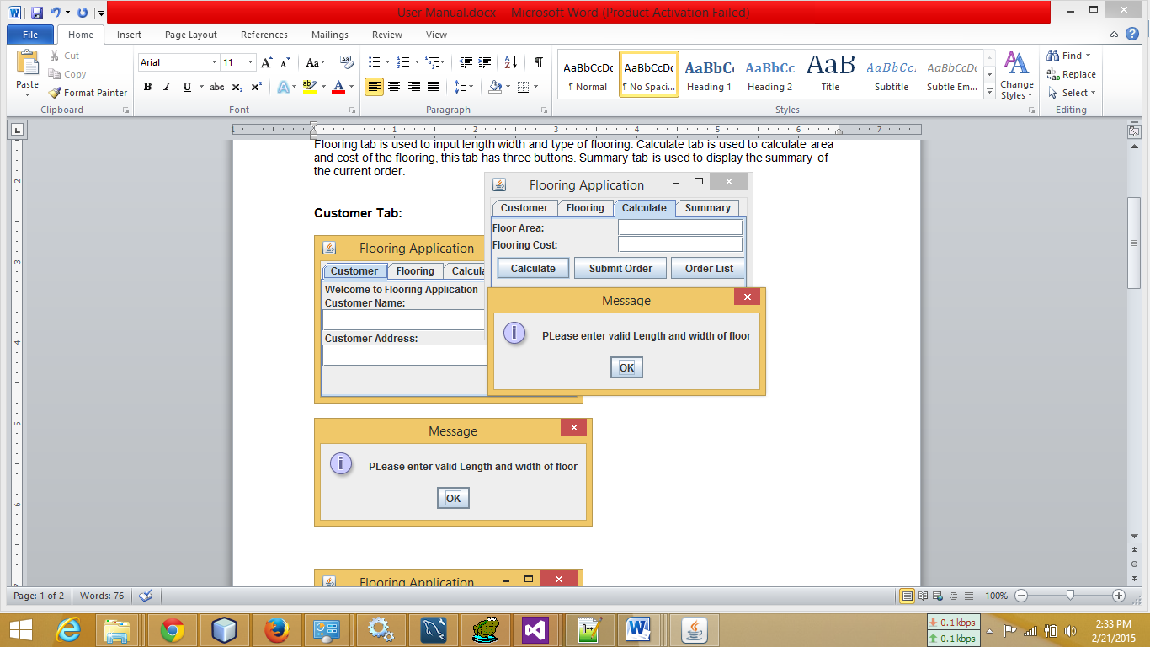

If flooring type is not selected following message will be displayed.

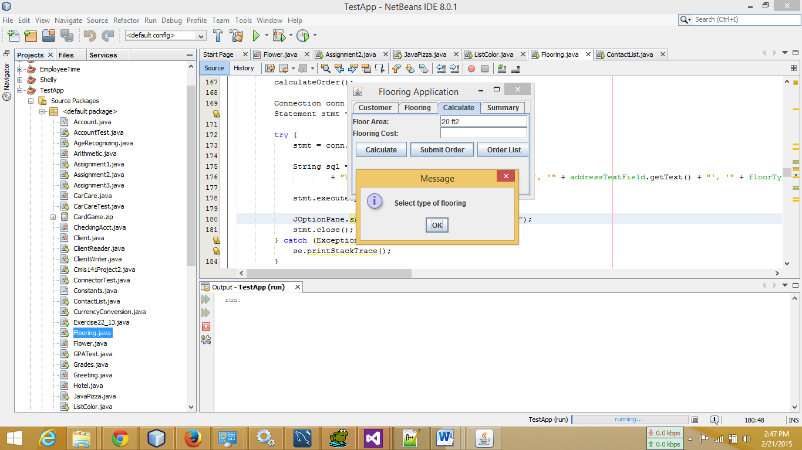

**Summary Tab:**

Summary tab is used to display details of the current order.

Following is the screenshot of the summary tab.

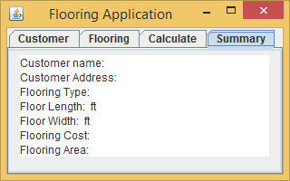

**Calculate Tab:**

Calculate tab is used to calculate flooring area and cost. It has Calculate, Submit Order and Order List buttons.

Following is the screenshot of the calculate tabs:

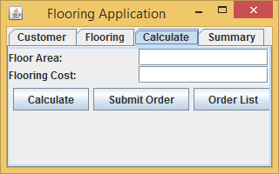

Calculate and submit button validates that correct values are entered in customer name, customer address, length of floor, width of floor and type of flooring.

Order list is used to display the list of orders save in the database, following is the screenshot of the output screen.

